

Misys Hospital Systems
Employee Education



Siebel 7.5 for MHI

Siebel for Support
Copyright ©
2003, 2004
Misys Hospital Systems, Inc.,
d/b/a Misys Healthcare Systems

All Rights Reserved

Publishing History:
Date: September 2004
Revision: 0

Table of Contents
Getting Started 1
Objectives: 1
References: 1
Logging In 2
Getting Started, continued 3
Web Browser Settings 3
F11 3
Internet Explorer Options 3
Refresh Button 3
Siebel Application Window 4
Home Page 4
Home Page Customization 5
Application Window 6
Application Level Menu 7
Branding Area 7
Siebel Application Toolbar 7
Show Drop-Down List 8
History Button 8
Thread Bars 9
Back/ Forward Navigation Buttons 9
Help/FAQ 9
Site Map Button 10
Report Button 10
Queries Drop-Down List 11
Keyboard Shortcuts 11
Screen Tabs 13
Views Tabs 13
Displaying Records 13
List 14
Form 14
Records and Fields 15
Text Fields 15
Drop-Down Lists 15
Field Control Buttons 15
Saving Data in Fields 16
Canceling Changes 16
Using Hyperlinks 16
Menu Button 17
Right- Clicking 17
Show More Button 17
Organizing Columns 18
Resizing a Column with the Mouse 18
Moving a Column with the Mouse 18
Sorting Records in a List 18
Columns Displayed Dialog Box 19
Exercise 1: Using the Column Arrangement Feature 20
Group Exercise 20
Searching for Records 21
Searching for Records 21
Search Operators 21
Accessing Search 21
Search Dialog Box 22
Exercise 2: Using the Search Feature 23
Group Exercise 23
Querying for Records 24
Query Icons 24
Query Button 24
Query Operators 26
Exercise 3: Performing a Basic Query 27
Group Exercise 27
Exercise 4: Perform a Refined Query 28
Group Exercise 28
Exercise 5: Using the Query Assistant 29
Group Exercise 29
Exercise 6: Exporting, Saving and Deleting a Query 30
Group Exercise 30
Report Viewer 30
Introduction 31
Illustration 31
Toolbar Buttons 32
MISYS Specific Procedures 33
Siebel For Developers & Support Scenarios- Getting Started 34
Adding a Record 34
Procedure 34
Associating a Record with Another Record 34
Procedure 34
Spell Checking 34
Attaching a Document to a Record 35
Procedure 35
Siebel For Developers Scenarios- Getting Started 36
Scenario 1: Incoming Call 36
Scenario 1-1 Locating a Change Request 36
Group Exercise 36
Scenario 1-2 Creating a Change Request 37
Group Exercise 37
Scenario 1-3 Create an Activity and Attachment for the CR 39
Group Exercise 39
Scenario 1-4 Associate Service Request to a Change Request 40
Group Exercise 40
Scenario 2: Incoming Call Follow- Up 41
Scenario 2-1 Locating and updating a Service Request 41
Group Exercise 41
Scenario 2-2 Creating An Activity for a Service Request 42
Group Exercise 42
Scenario 3 – Updating A Service Request 44
3-1 Locate an Existing Service Request 44
Group Exercise 44
Scenario 3-2 Create an Activity and Attachment for the SR 45
Group Exercise 45
Scenario 4: Account Management 46
Scenario 4-1 Locate an Account and Create an Activity 46
Group Exercise 46
Scenario 4: Account Management 47
Scenario 4-2 Record an Account Note 47
Group Exercise 47
Additional Siebel For Developer Exercises 48
Customizing the User Interface 51
Customizing Your Home Page 51
Using the Home Page Controls 51
Editing the Page Layout 52
User Preferences 52
Updating Profile and Behavior Settings 53
Time Zone Preferences 53
Setting a Startup View 53
Modifying the History List 54
Setting Up Default Queries 54
View Personalization 55
To show or hide screen tabs 55
To show or hide view tabs 55
To change the order in which screen tabs appear 55
To change the order in which view tabs appear 56
To set up a default view for a screen 56
Training Course Evaluation 57

Getting Started

Objectives:
By the end of this course you will be able to:
- Describe how to navigate Siebel 7.5
- Describe the call center/ support workflow as it relates to Siebel
- Manipulate data according to our workflow
- Locate data with query and find features

References:
CM Product Change Request Procedure (CM 02). This procedure describes at a high level, the processes for documenting, updating and resolving software defects, enhancements and/or user document changes via a Change Request (CR) during development phases prior to and after release of a product for distribution. It provides details on each of the fields in a Siebel Change Request/Enhancement record.

CM 02 can be found in:

\\athena\qsl\Department Procedures\Configuration Management\Current Procedures

Logging In
To begin, we will discuss how to access the Live Siebel Application. To access Siebel go to the URL siebel or type the word Siebel into your Internet Explorer address field. For training purposes we will use the Internal Siebel training area. To access this area, type siebelinternal into the URL.

My USER ID:

My PASSWORD:

Login screen appears

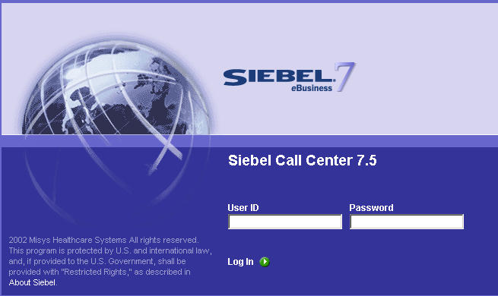

Getting Started, continued

Web Browser Settings
It may be necessary to change some of your Internet Explorer settings in order to view the Siebel Application and utilize the application with ease and optimal use.

F11
Use your F11 key when you enter the Siebel Application. This will give you more “real estate” to work with. In other words you will be able to see more of the application. It will also keep you from using your browser’s back and forward buttons.

Internet Explorer Options
You will also want to verify that you have a setting in the Internet Options set so that the Siebel Application is not replaced by another web application, or web page.

Step 1: Start Internet Explorer
Step 2: Choose Tools > Internet Options
Step 3: In the Internet Options dialog box, click on the Advanced tab.
Step 4: Under Browsing, clear the Reuse windows for launching shortcuts check box.
Step 5: Click OK.

Refresh Button
For remote users, click the Refresh Button in your Web browser when your application times out and you need to re-login.

Siebel Application Window

Home Page
The Home Page is the first page you will see when logging into the Siebel Application. This page is meant to give you an easy way to link to frequently accessed application functionalities. You can customize your home page to work according to how you would like it set up.

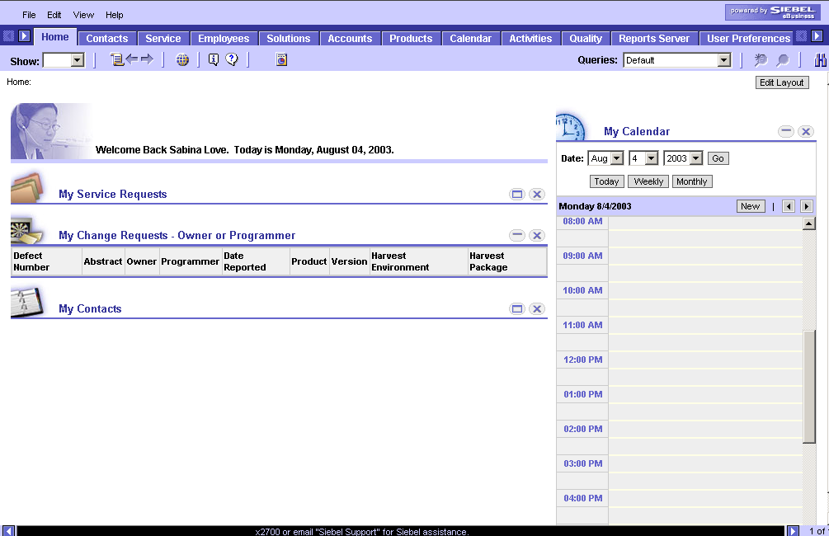

To remove content from your home page, click the X at the far right of the particular content.

Home Page Customization

To customize your home page, click the Edit Layout button in the top right hand corner of the home page.

Any tabs not on your home page will be grayed out on the Edit Layout page. To add any particular content to your home page, click the checkmark to the right of the grayed out tab (see below)

***Note***
The My Calendar, My Appointments and My Contacts do not sync up with your outlook.

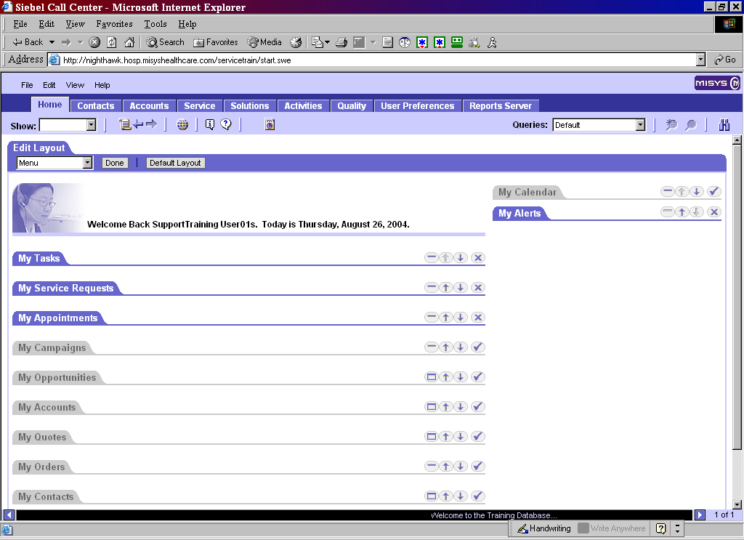

Siebel Application Window, Continued

Application Window
Siebel applications present a standard framework referred to as the Siebel application window. In this section we will discuss the structure of the Siebel Application including how to navigate.

This is an example of the Siebel Application Service Screen.

Form applet
List applet
Message bar
Screen Tabs
View Tabs
Toolbar
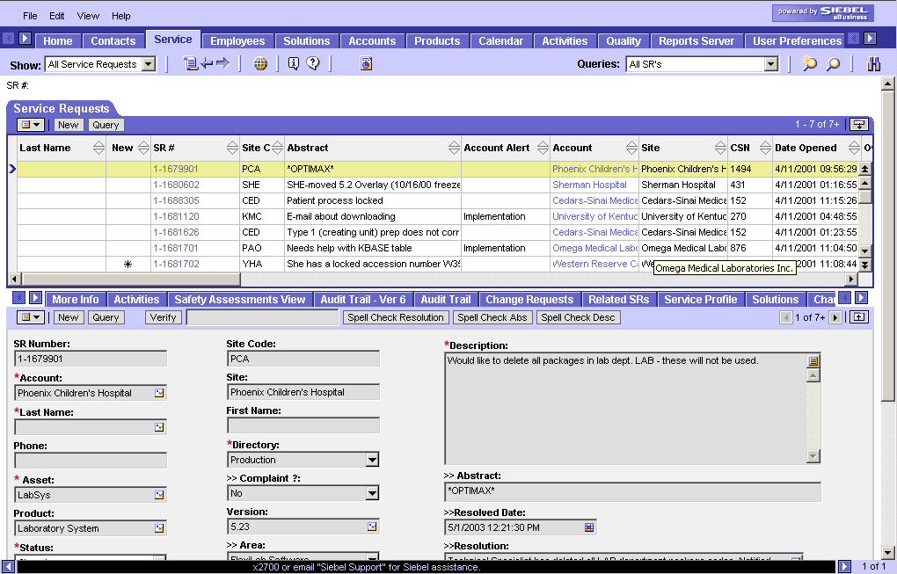
Siebel Application Window, Continued
Show drop-down list  History Button  Navigation Buttons  Site Map  Help/FAQ  Report Button  Query drop-down list  Query Buttons  Search Button | Application Level Menu  This menu is located in the left corner of the application window. The menu consists of a File, Edit, View, and Help option. Common Siebel functions can be accessed here, but can also usually be accessed via icons within the application.  Branding Area  If you click on the branding area in the “live” area you will be routed to Misys Healthcare’s web page. The web page will appear in a separate browser window.    Siebel Application Toolbar  The Application Toolbar allows you to access frequently used tools such as the Show drop-down list, history button, navigation buttons, site map, Query drop-down list, query buttons and search button.

Siebel Application Window, Continued

Show Drop-Down List
The Show drop-down list displays the names of filters. Examples of the type of filters you may find in the list for instance are My Service Requests, All Service Requests, My Activities, All Activities and so on.

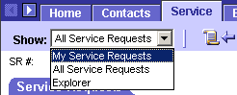

History Button
The tools available on the History bar offer visual landmarks of the views that have been used and the drill-down threads followed during a working session. The history button displays a list of the most recent views that you have visited within the Siebel application. It updates every time you move to a new view.

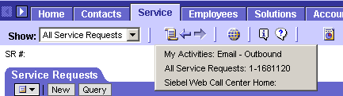

Example
If a telephone call interrupts workflow by requiring the user to access the calendar for confirmation of a meeting time, one click in the History List drop-down quickly returns to the work in progress prior to the interruption.

Siebel Application Window, Continued

Thread Bars
The Thread bar maintains a record of the drill-down paths that have been taken. It allows the user to return to any of the views in that path by clicking the appropriate button.

As different views relating to one record are accessed, the system displays the navigational path in the Thread bar. The Thread bar is a series of buttons related to the views of the record that have been accessed. Clicking a button on the Thread bar returns the display to the view referenced by the button.

Back/ Forward Navigation Buttons
When users are progressing through a series of steps in a business process, the Back and Forward arrows allow navigation through screens and views previously accessed. Navigation with these arrows is analogous to their use on the Internet. The back and forward navigation buttons return you to the last screen or view that you visited.

Do not use your Web browser’s back and forward buttons to return to screens or views!

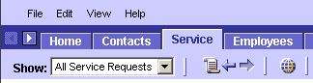

Help/FAQ
Online help provides you with the information you need to start using your Siebel application. Frequently Asked Questions (FAQ) is a place to go before contacting the CMS team about a question you have with the Siebel application.
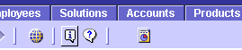

Siebel Application Window, Continued

Site Map Button
Use the Site Map button to view the site map, which gives you hyperlinks to accessible areas on Siebel. Clicking the Site Map button will show you a listing of all the screens available to you.

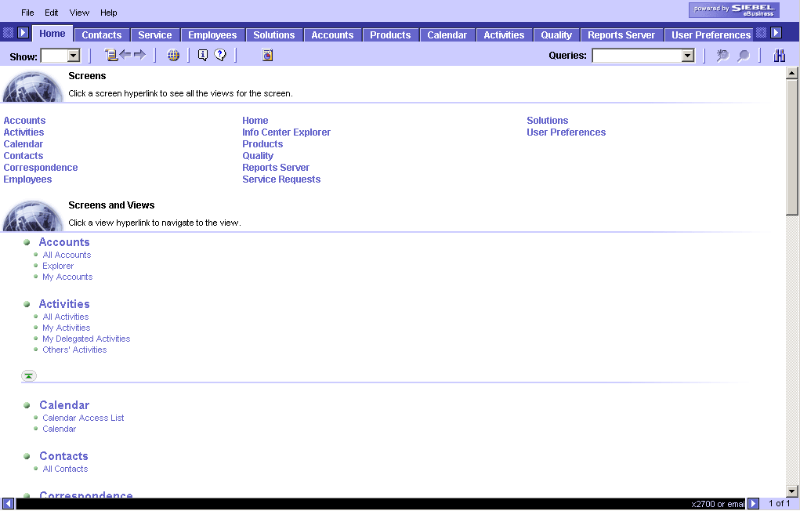

Report Button
We will discuss reporting capability later in the session.

Siebel Application Window, Continued

Queries Drop-Down List
Provides you access to your saved queries and to predefined queries.
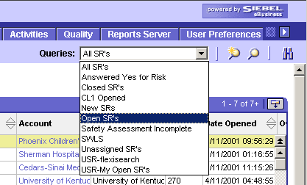

Keyboard Shortcuts
Keyboard shortcuts allow you to use keystrokes as an alternative to the mouse for executing commands and for navigating the Siebel application. Many of the Siebel functions have keyboard shortcuts. You might choose to use keyboard shortcuts to navigate the application more quickly.

Keyboard Accelerators
Record Management | Shortcut
New Record | CTRL + N
Copy Record | CTRL + B
Save Record | CTRL + S
Undo Record | CTRL + U or ESC
Select All Records in List | CTRL + A
Record Navigation | Shortcut
Next Record | CTRL + Down Arrow
Next Page of Records | ALT + Down Arrow
Last Page of Records | ALT + L
Previous Record | CTRL + Up Arrow
First Page of Records | ALT + F
Next Field | TAB
Previous Field | SHIFT + TAB
Query Management | Shortcut
New Query | ALT + Q
Execute Query | ALT + ENTER
Save Query | ALT + S
Refine Query | ALT + R
General Navigation | Shortcut
Go To Site Map | CTRL + SHIFT + A (tlas)
Open Search Center | CTRL + F (ind)
Go To History Button | CTRL + Shift + H (istory)
Open Applet-Level Menu | CTRL + SHIFT + M (enu)
Run Report | CTRL + SHIFT + R(eport)
Layout Management | Shortcut
Define Columns Displayed | CTRL + SHIFT + K
Define Sort Order | CTRL + SHIFT + O (rder)
Online Help | Shortcut
Open Online Help | CTRL + H (elp)
Help with Record | CTRL + ALT + K
Technical Support | CTRL + ALT + J
Application Management | Shortcut
Re-connect after Timed Out | F5 (Refresh)
Connect as New User | CTRL + SHIFT + W
Log Out | CTRL + SHIFT + X

Screens and Views
The Siebel application windows are split horizontally. The screens will appear on top and the corresponding views will appear on the bottom. Each screen will have a different set of views available. Field entry applets are used to enter information. These fields comprise a record. You will find records arranged in list applets and form applets. Each of these components will be defined for you.

Screen Tabs
The Siebel application is organized into screens. Examples of common screens you may access are the Service, Contacts, Accounts, Quality, and Solutions Screens. To access the screen of interest you will click the screen tab.

Views Tabs
As previously mentioned each screen has corresponding views. The views might be used to attach documents, add activities, or even associate change requests.

Displaying Records
Records can be displayed in a list or form applet. In some instances you may have the choice of using a list or a form, but in many cases you may need to at least complete mandatory fields in order to hyperlink to the form applet.

Screens and Views

List
Lists consist of multiple records in rows. Each record consists of multiple fields. In order to see all of the fields in the list you may need to use scroll bar. Clicking on any field in the record selects the record. You can tell because it will be highlighted. You can edit fields within the list applet if the fields are editable.

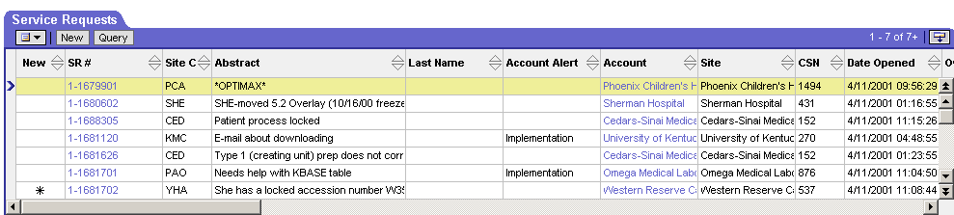
Field names (also known as ‘Columns’)
Scroll Bar to see all Fields in list applet

Form
A Form displays one record at a time. The record that will display in the form is the record you have highlighted in the list. When you drill down (hyperlink) on a record in a list you see a form. You can make edits directly within the form if fields are editable.

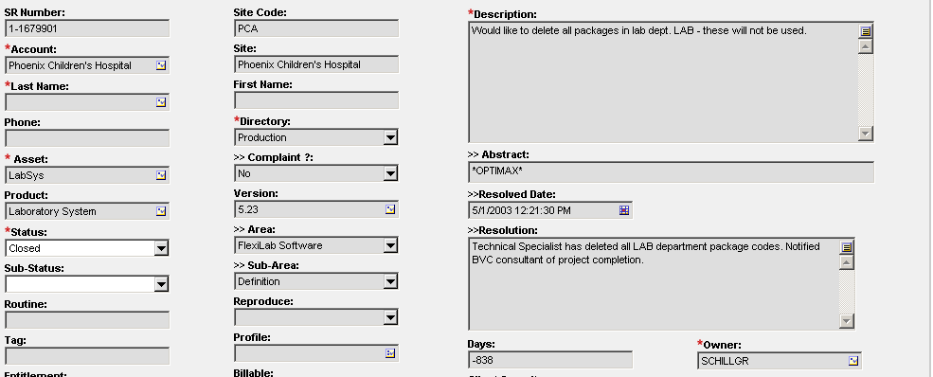

Siebel Components

Records and Fields
A record is a group of related data organized into fields.

Text Fields
Text fields allow you to type text directly into them.

Drop-Down Lists
Use the drop-down button to the right of a field to select from a list of available values.

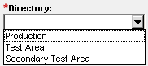

Field Control Buttons
Field Control Buttons allow you to select or attach a record that is appropriate to the field.

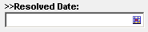

Siebel Components, Continued

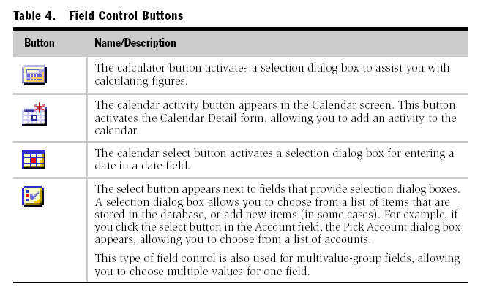

Saving Data in Fields
To save the data you have entered in the fields you can step off of the record to commit the changes to the database, click the menu button and then click Save Record, or choose File > Save Record from the application menu.

Canceling Changes
You can only cancel changes if record has not been saved. To cancel changes, click menu button and click undo record.

Using Hyperlinks
Hyperlinks may appear in a record that is in a list. Hyperlinks are blue text that become underlined when the cursor passes over it. Clicking on a hyperlink allows one-click access to detailed or additional information. You may hear some people calling this “drilling down.”

Siebel Components, Continued

Menu Button
The Menu Button displays a menu of actions that apply to the active form or list. Examples of options that you could access include copy, edit, delete, query, and columns displayed.

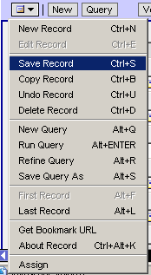

Right- Clicking
Right-clicking in a form or list is another way to activate the same menu of actions provided by the menu button.

Show More Button
Every form or list has a show more button in the top right corner. It is used to expand or collapse the form or list. If you click the Show More button when in a form you will be able to see more or fewer fields depending on if you are expanding or contracting the form. Clicking Show More when in a list allows you to look at more or fewer records.


“Show More” “Show Less”

Column Arrangement

Organizing Columns
A list consists of many columns of data, some of which may not be displayed onscreen. Depending on your workflow, you may choose to add, remove, or rearrange the columns in the order that works best for you.

Resizing a Column with the Mouse
To make viewing records in a list applet easier, the order of the columns can be changed and their width resized to show more or less of a particular field.

To resize a column, locate the mouse over the column edge until the cursor becomes a two-sided arrow. Click and drag the column header until the desired size is reached.

Moving a Column with the Mouse
To move one column ahead of another, click the column header and drag right or left until a red line appears. When the appropriate position is reached, release the mouse.

Sorting Records in a List
Records in a list can be sorted by a column. The Sort button allows you to perform one sort within the list applet. A green up arrow indicates that the sort is in ascending order. A green down arrow indicates that the sort is in descending order.

Column Arrangement, Continued

Columns Displayed Dialog Box
To rearrange several columns at once, or if the columns to be moved are far apart, the easiest solution is to use the Columns Displayed dialog box. To activate the dialog box, right-click inside a list applet and choose Columns Displayed from the shortcut menu that appears.

This is an example of the Columns Displayed dialog box.
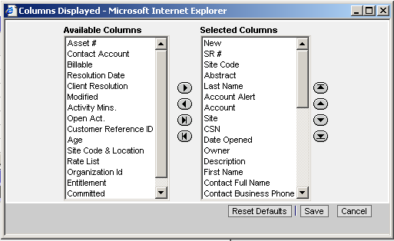

Note: Settings chosen from the Columns Displayed dialog box are saved between sessions. This means that when a user exits and re-opens the application, the settings are still active.

Exercise 1: Using the Column Arrangement Feature

Group Exercise | According to your workflow you would like to see Site Code, Status, and Date Opened as your first columns. You also don’t need the Group column.  Follow the steps below to use the Column Arrangement function

Step | Action
1 | Right Click on the Columns in the list applet and choose the Columns Displayed option.
2 | Use the up and down arrow buttons to arrange the Site Code, Status and Date Opened fields to the top.
3 | Use the left arrow button to move Group to ‘Available Columns’
4 | Press Save – View the columns

Searching for Records

Searching for Records
Siebel applications are equipped with a Search feature that allows the user to quickly locate a specific record from anywhere in the application.

This is an example of the Search button.


Search Operators

Operator | Description
* | Placed anywhere in a string, returns records containing the string or containing the string plus any additional characters at the position at which the asterisk appears, including a space. For example, *rang* finds arrange, arranged, orange, orangutan, range, ranges, rang, strange, stranger, and so on. It is not necessary to put a wildcard at the end of the word; for example, Sieb will return Siebel.
? | Placed anywhere in a string returns records containing the characters specified in the string, and also containing any single character at the location of the question mark. For example, ?rag fins brag or drag, but not bragging. t?pe finds type, tape, but not tripe. To find a question mark, precede the question mark with a backslash. Type \? To find strings that contain a question mark.

Accessing Search
There are three methods available for activating the Search Center.

- Click the Search button on the toolbar.
- Select Search from the View menu.
- Press CTRL+F.

Searching for Records, Continued

Search Dialog Box
When locating records, it may be more practical to enter only the first few letters of a name or word, especially if the exact spelling is unknown.

For this reason, Search also recognizes an asterisk as a wildcard (*). As an example, when looking for a specific account, such as Layton Industries, a user can type only Lay* in the Account Name field.

This is an example of a Find dialog box.

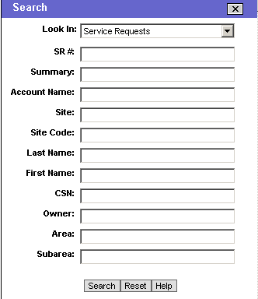

Note: There are several options in the “Look In” drop-down box, and the search fields will change accordingly.

Exercise 2: Using the Search Feature

Group Exercise | You receive a call from Donna Galaska at Advanced Healthcare and you need to quickly locate her record.  Follow the steps below to use the Find function

Step | Action
1 | Click the Search button on the toolbar.
2 | Select Service Request in the Look In drop-down.
3 | Type Galaska in the Last Name field.
4 | Click Search – View the results

Querying for Records

Querying for Records
Querying for records is useful when you have 1 or more pieces of information from a record that you would like to find. Each field in a record can be queried on. By doing a query you are searching the database for a specific subset of data based on one or more conditions or criteria. Some queries have been predefined for you. You can also save new queries, so that you can access them a later time.

Query Icons
You can use the Query Icons to initiate and execute a query.

Start Query Execute Query

Query Button
The Query button appears on forms and lists. It is another way you can execute a query. When you click the button the record fields will go blank. You will fill in only the fields you would like to query by.

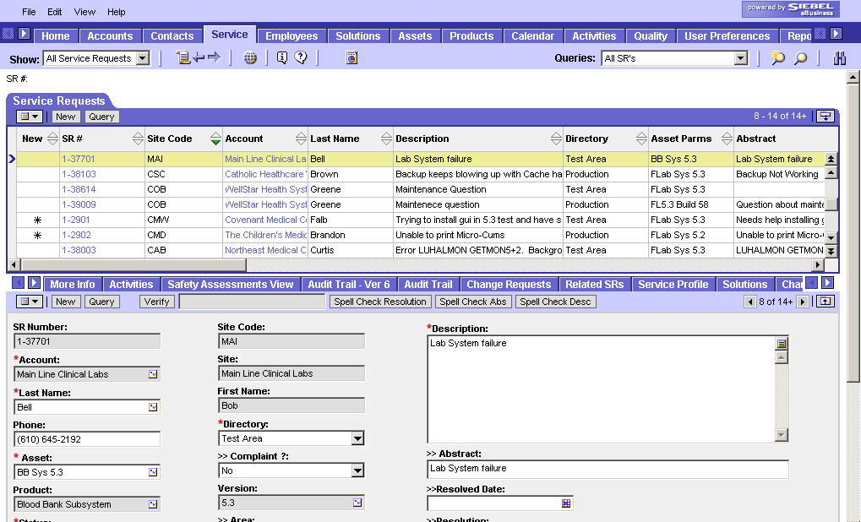

Querying for Records, Continued

Queries Drop-Down List

The Queries drop-down list provides access to your saved queries and to predefined queries.

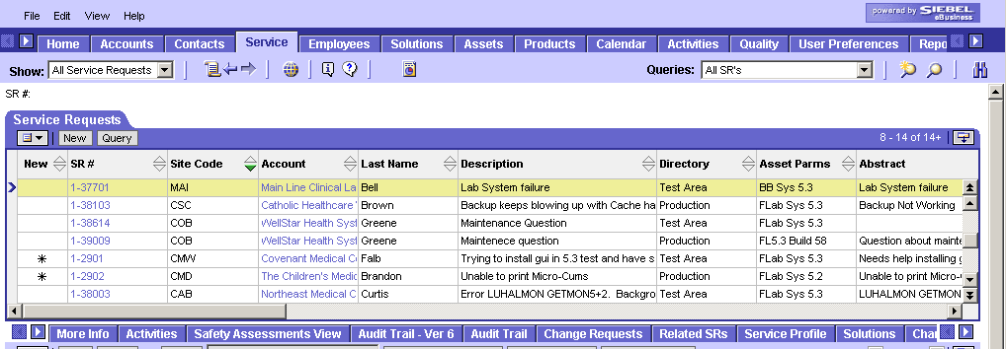

Querying for Records, Continued

Query Operators

Operator | Description | Example
= | Equal to | =CA retrieves all records in which the value in the query field is CA
< | Less than | <4/25/03 retrieves all records in which the value in the query field is before the given date.
> | Greater than | >4/25/03 retrieves all records in which the value in the query field is after the given date
<> | Not equal to | <>CA retrieves all records in which the state is not CA
<= | Less than or equal to | <=4/25/03 retrieves all records in which the value in the query field is on or before the given date
>= | Greater than or equal to | >=4/25/03 retrieves all records in which the value in the query field is on or after the given date
* | Wildcard | Sie* retrieves any names that begin with the letters Sie. Wildcards can also be placed in the middle or at the beginning of a text string.
? | Question Mark | Placed anywhere in a string returns records containing the characters specified in the string, and also containing any single character at the location of the question mark. For example, ?rag finds brag or drag, but not bragging. t?pe finds type, tape, but not tripe. To find a question mark, precede the question mark with a backslash. Type \? To find strings that contain a question mark.
“” | Double quotes | “Siebel Systems” retrieves all records that contain Siebel Systems in the query field. Text in double quotes, unless modified by a wildcard, must match exactly. If your query includes a blank space, you must enclose the query between double quotes or the space will be ignored.
~LIKE | Approximately | Placed before LIKE and a value with a wildcard operator, returns all matching records regardless of case ~LIKE Smi* finds all records in which the value in the query starts with Smi, smi, SMI, and so on.

Exercise 3: Performing a Basic Query

Group Exercise | You need to call the Project Manager at Adventist Health Systems and would like to quickly locate her number.  Follow the steps below to perform a basic query.

Step | Action
1 | Click the Accounts screen
2 | Click the New Query button on the toolbar
3 | Type Adventist * in the Account field.
4 | Press Enter on the keyboard to execute the query, or click Execute Query button on the toolbar.
5 | Hyperlink to the AHSCORP and review contact results

Exercise 4: Perform a Refined Query

Group Exercise | You receive a call from St Mary’s Hospital and need to locate their site code. Follow the steps below to refine a query.

Step | Action
1 | Click the Accounts screen
2 | Click the New Query button on the toolbar.
3 | Type St. Mary* in the Site field, and Press Enter on the keyboard. (View the results- several accounts with “St.Mary’s” in the name will appear).  Hint: Make sure you are on “All Accounts” in the Show drop-down menu.
4 | Click on the Edit menu, and select Query>Refine.  Hint: Make sure you are using the Siebel menu, not the browser menu.
5 | Enter 706* in the Main Phone number field. (Further refining the query)
6 | Press Enter on the keyboard to execute query, or click the Execute Query button on the toolbar. (View the results)

Exercise 5: Using the Query Assistant

Group Exercise | You would have multiple pieces of information and would like to use the query assistant to perform a query for a system manager list in Michigan.  Follow the steps below to find information using the query assistant.

Step | Action
1 | Click the Contact screen
2 | Click the Query button at the top of the list applet.
3 | Click the Query Assistant button at the top of the list applet
4 | Click the drop down in the first row <Select Field> area and select Contact Type
5 | Skip to the last dialog box in the first row and enter *Sys*
6 | Click the drop down in the second row <Select Field> area and select State
7 | Skip to the last dialog box in the second row and enter MI
8 | Click the Go button at the bottom
9 | View the results

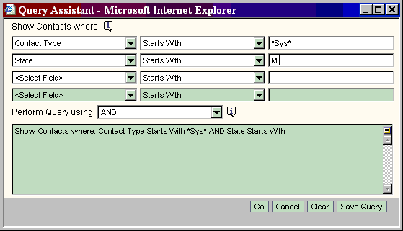

Exercise 6: Exporting, Saving and Deleting a Query

Group Exercise | You would like to export the information from the previous exercise for future use.  Follow the steps below to do and save a query.

Step | Action
1 | Right Click on the List Applet and Choose Export
2 | A dialog box will appear  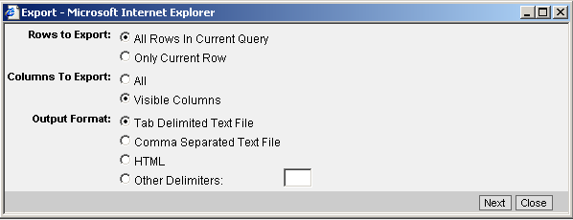  Choose “All Rows in Current Query”, “Visible Columns”, and Export the query as a “Tab Delimited Text File.” You will be able to open this file in Excel.  Click Next  Note: If you only want certain columns, you need to change your columns displayed.
3 | The data will Export, and you will be prompted to open it or save. Click Save. Save the file to your desktop.
4 | Go to your Desktop and Open the Excel file.
5 | Close the Excel spreadsheet
6 | Click Edit on the menu bar and select Query > Save Query As.
7 | Type MI System Manager in the Query name field. Click OK
8 | View your Saved Queries Drop-down (Your new query name will appear in the box)
9 | Click Edit on the menu bar and select Query > Delete.
10 | In the Delete Query box, select MI System Manager
11 | Click OK to delete the query.

Report Viewer

Introduction | After a report has been generated, it is viewed through the Report Viewer. Users can manipulate the report in a number of ways by using the Report Viewer toolbar.

Illustration | This is an example of the Siebel Report Viewer.
Record data  Data labels  Report Viewer toolbar  Page header | 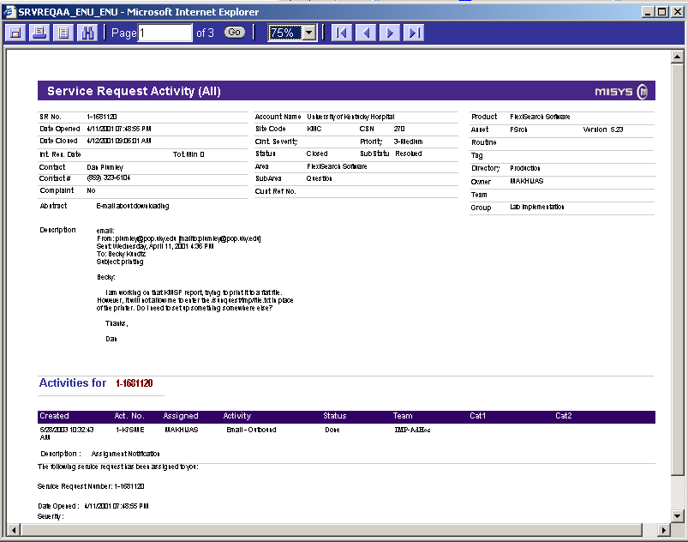

Continued on next page
Report Viewer, Continued

Toolbar Buttons | This table lists and describes the buttons on the Report Viewer toolbar.

Button | Function | Description
 | Download or Print Report | Prompts you to covert the report to a .pdf then you can save the report within Acrobat.
 | Download or Print Report | Sends the report to .pdf and then you can send it to the printer.
 | Report Navigation | Allows you to hyperlink to the records in your report.
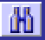 | Search | Gives you the option to search record fields within the report.
 | First Page | Returns to the first page of the report
 | Next Page | Advances to the next page of the report
 | Previous Page | Returns to the previous page of the report
 | Last Page | Advances to the last page of the report
 | Go to Page | Navigates to a specific page in the report
 | Zoom | Increases or decreases how much of the report you see at a time.

MISYS Specific Procedures
The following section will provide you with practice scenarios to educate you on the Siebel system. You will apply the knowledge you have gained through the overview training towards the following situations.

The system and procedures discussed may be modified in the future due to changes in business practice.

Siebel For Developers & Support Scenarios- Getting Started

Adding a Record

Procedure
Step 1: Starting a new record-
Click the New button or,
Click the Menu button, and then New Record or,
From the application menu choose File > New > Record or,
Right-click in a list or form and choose New Record or,
Use the keyboard shortcut Ctrl + N
Step 2: Entering the data-
You will see a new row in a list or a new form in which to enter your data
- Mandatory fields to open indicated by red asterisk
- Mandatory fields to close indicated by >>

Associating a Record with Another Record
Example Change Request associated to Service Request

Procedure

Step 1: Navigate to the appropriate screen.
Step 2: Select the record with which you want to associate your chosen record.
Step 3: Click the appropriate view tab.
Step 4: In the selected view, click New. Depending on which view you are in, a blank record or a selection dialog box appear.
Step 5: Do one of the following:
Select the record you want to associate from the dialog box and click OK.
Complete the fields of the blank record, thus adding a new record.

Note: You may not be able to associate records in all screens

Spell Checking
Spell checking can be performed in a number of places within the application. You will see a Spell Check button. Spell checking is especially useful in fields such as: Abstract, Description, and Resolution

Attaching a Document to a Record
You can attach any file type to a record. This is useful when a client sends a document that you would like to attach to the record for others to view. Files can be attached to records wherever the Attachments view is available within a screen

Procedure
Step 1: Select the record to which the attachment will be added.
Step 2: Click the Attachments view tab.
The Attachments list appears.
Step 3: Click New.
A blank record appears.
Step 4: Click the Attachment Name select button.
The Add Attachment dialog box appears.
Step 5: Click Browse.
The Choose file dialog box appears.
Step 6: Locate and select the file, and then click Open.
The file appears in the File Name field in the Add Attachment dialog box.
Step 7: Click Add.
The Add Attachment dialog box closes and the record appears in the
Attachments list with the appropriate fields filled in.

Siebel For Developers Scenarios- Getting Started

Scenario 1: Incoming Call

Scenario 1-1 Locating a Change Request

Group Exercise | You need to check the status of a change request pertaining to the FlexiLab Ad Hoc Report Writer CR# 1-V69.  Follow the steps below to locate the Change Request.

Step | Action
1 | Click the Quality Tab at the top of the screen
2 | Click the Query button on the toolbar.
3 | Click inside the Change Request field.
4 | Type 1-V69 in the CR# field.
5 | Click Execute Query button.
6 | View the results.

Scenario 1-2 Creating a Change Request

Group Exercise | You have discovered a bug in the Billing Software; you have created a project and now need to enter a change request for a product defect.  Follow the steps below to create a change request.

 | Step | Action
 | 1 | Quality Screen / All Change Requests View, Click on the New button on the form applet.  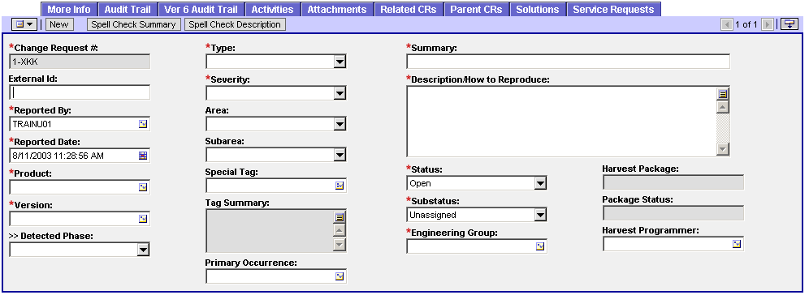  Change Request Number: Auto populates by system  External ID: ID number from another tracking system, i.e. ^PRJ  Reported By: Auto populates with your login name.  Reported Date: Date the change request was reported/entered into Siebel  Product: Select the application the defect was reported in.  Version: Type in the version of the product the defect was reported on.  Detected Phase: Phase of development in which the defect is reported  Date Reported: Select the date and time the defect was reported in the calendar drop down box  Type: The type of change request being logged here  Severity: Select the intensity of the defect.  Area: Product and module  Sub-area: Further specified area information  Special tag: Refer to department specific instructions  Tag Summary: Refer to department specific instructions  Primary Occurrence: Cross reference to another change request
Summary: Type in a one line summary of the defect
Description: Enter more detailed information about the change request and or instructions on how to reproduce the issue.
Status: Current status of the change request: open, closed, cancelled
Sub-status: Additional status information based on where the CR is in its lifecycle
Engineering Group: The group assigned to fix the problem
Harvest Package: A code representing the unit of work in Harvest
Package Status: Reflects the status of the package in its lifecycle within Harvest. This field updates automatically if the Siebel/Harvest web interface is active.
Harvest Programmer: The programmer assigned to code the fix who is using Harvest to manage the code
There are many additional fields. Check with your department to see if you should use any of them. The following fields are mandatory to close a change request:
Detected phase: Select the option that indicates where the defect was identified
Owner: who owns the change request
Cause: Select the category of the defect’s cause
Fixed version: the version of the product where the fix was installed
 | 2 | Complete the following fields  Product: FlexiLab  Version: 5.3 (pick any build you like for this example)  External ID: PRJ Ref: B-PRINT  Severity: 3  Abstract: Printer data collides  Type: Software Defect  Area: FL-General Lab  Description: Data collision is causing errors and halting print jobs  Priority: High  Write down the Change Request number.

Scenario 1-3 Create an Activity and Attachment for the CR

Group Exercise | Now that you have entered the change request for the billing software, you must create an Activity and Attachment to include your link session.  Follow the steps below to create the activity and attachment.

Step | Action
1 | In the Quality screen / Activities view, in the Activities list applet select New.
2 | Complete the following fields in the Activities List Applet  Team: select BIL –Billing  Activity Type: Documentation  Description: Link session to site  Visibility: SQ Eyes Only
3 | Click back on the Activity Type field and drill down to the Activity form applet.
4 | Complete the following fields:  Duration: 15m minutes  Actual Start: Today’s date  Comments: See Attachment  Status: Done
5 | In the Activities Screen / Attachments View click in the Attachments List Applet and Select New File.
6 | In the Select file dialog box,  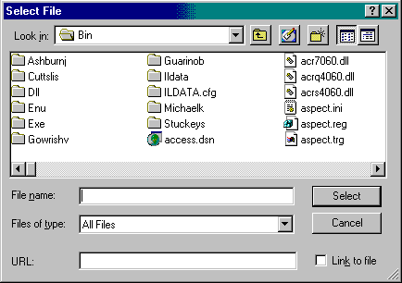  Select your link information file

Scenario 1-4 Associate Service Request to a Change Request

Group Exercise | You now need to attach an existing service request to this product defect. Follow the steps below to create the attachment.

Step | Action
1 | Click the Quality Tab at the top of the screen. Make sure the Show drop down box is set to All Change Requests
2 | Click the New Query button
3 | Click inside the Change Request field
4 | Type your change request number from Scenario 1-2 in the CR# field
5 | Click the Execute Query button
6 | While still displaying your change request, switch to the Service Requests view; Click in the Service Request list applet and Select New Record
7 | In the Service Request Pick box choose any Service Request.  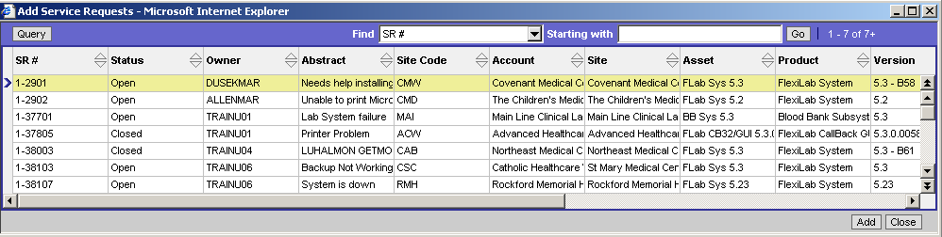
8 | Click ADD in the Service Request pick box
9 | View your Service Request now associated to the Product defect.

Scenario 2: Incoming Call Follow- Up

Scenario 2-1 Locating and updating a Service Request

Group Exercise | You receive a call from Steve Tse at site NAH providing you with information from a previous call.  Follow the steps below to locate the service request.

Step | Action
1 | Click the Query button on the toolbar.
2 | Click in the Service Request field and enter SR# 1-48836. Click on the Execute Query button
3 | View the results

Scenario 2-2 Creating An Activity for a Service Request

Group Exercise | Now that you have located the service request for site NAH, you must create an activity to record the client’s request.  Follow the steps below to create an activity for the service request.

Step | Action
1 | In the Service screen / Activities view
2 | In the Activities List Applet and select New Record.
3 | Click the drop –down arrow in the Type field and select Call.
4 | In the Description field, type question about maintenance
5 | Click the drop-down arrow in the Visibility field and select Customer Viewable
6 | Go back to the activity type and drill down to the form applet

Group Exercise (continued)
 | 7 | 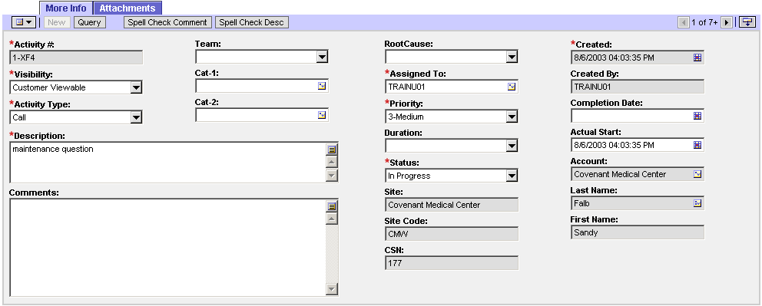  Activity ID: System assigned  Visibility: Setting determines if Client can view the information or Misys only  Activity Type: Categorization of Activity that was used to solve the service request.  Description: A summation of the activity.  Comments: Limited to 2000 character description of activity. Use attachments for longer task description.  Team: The team this activity was performed by.  CAT-1, CAT-2, Root Cause – Refer to department specific training.  Assigned To: The owner of the activity.  Priority: Misys prioritization of the activity  Duration (MIN): Amount of time spent on activity (This number will be use to determine productivity). The system can calculate minutes from hours.  Status: The status of the activity. (To make status done, you must be the owner of the activity) (The Activity can no longer be opened once status is changed to done –read only)  Site/Site code/CSN fields: populate from the Service Request form  Created: Date the activity was created in the system  Created by: the person who entered the activity  Completion date: date the activity was completed  Actual Start: The date and time the activity actually started.  Account/Last Name/First name fields: populate from the Service Request form
 | 8 | Complete the following fields:  Duration: 10 minutes  Comment: Client gave detailed information.

Scenario 3 – Updating A Service Request

3-1 Locate an Existing Service Request

Group Exercise | You receive a call from Linda Cooke at site COB regarding microfiche.  Follow the steps below to locate the service request for COB.

Step | Action
1 | Click the Search button on the toolbar.
2 | Select Service Request in the Look In Section
3 | Type COB in the site code field
4 | Click Search
5 | View the results. (Service Request #1-39009 is displayed)
6 | Verify the information on the above Service Request.

Scenario 3-2 Create an Activity and Attachment for the SR

Group Exercise | Now that you have located the service request for site COB you must create an Activity and Attachment to include your link session.  Follow the steps below to create the activity and attachment.

Step | Action
1 | In the Service screen / Activities view, in the Activities list applet select New.
2 | Complete the following fields in the Activities List Applet  Team: select CS –Specialties  Type: Documentation  Description: Link session to site  Visibility: SQ Eyes Only
3 | Click back on the Activity Type field and drill down to the Activity form applet.
4 | Complete the following fields:  Duration: 30m minutes  Actual Start: Today’s date  Comments: See Attachment  Status: Done
5 | In the Activities Screen / Attachments View click in the Attachments List Applet and Select New File.
6 | In the Select file dialog box,  Select your link information file

Scenario 4: Account Management

Scenario 4-1 Locate an Account and Create an Activity

Group Exercise | You need to record a conversation that you had with site RCH  Follow the steps below to locate an Account and create an Activity.  Please note the site code is RCH and the site is Newberry County Memorial Hospital.

Step | Action
1 | In the Account screen / All Accounts view, query for site code RCH (Newberry County Memorial Hospital)  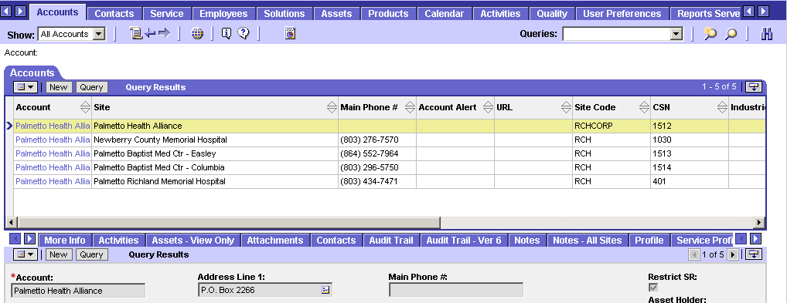
2 | In the Account screen/ Activities View
3 | Click on the Activities list applet, Select NEW record
4 | Complete the following fields on the Activities List Applet  Type Call  Description: Monthly Status Call  Call Duration: 60  Comments: No issues

Scenario 4: Account Management

Scenario 4-2 Record an Account Note

Group Exercise | You need to record that site AH3 will be adding a new HID  Follow the steps below to locate an Account and create a note

Step | Action
1 | Click the Search button on the toolbar.
2 | Select Account in the Look in Section
3 | Type AH3 in the Site Code field.
4 | Click Search and view the results
5 | Select Bolingbrook Medical Center
6 | Change to the Notes View
7 | Verify that the note is a Public Note and click New  Type: Note  Description: Site AH3 will be adding a new site.

Additional Siebel For Developer Exercises

Training database: http://siebelinternal/developertrain

General Workflow to Exercise Functionality

1. From the HOME page, click EDIT LAYOUT. Either make SHOW or HIDE the Contacts section (do the opposite of its current status on the home page). Remember to click SAVE.

Q: Did your change take effect?

2. Click on the Quality Tab. Create a new Change Request. Assign yourself as the owner. Write down the CR number: __________________

Q: How do you know which fields are mandatory?

Q: What button did you have to click to see the Owner: field (if it was not already showing)?

Q: On which applet is the Owner field found?

3. Use the menu button on the list applet for Change Requests, and click Columns displayed. Remove any two columns and reorder the remaining columns so that Status is the second column seen.

Q: What are the statuses of the Change requests seen in your list?

Q: What list are you viewing - based on your “Show” setting?

4. Sort the List applet on the Quality tab based on “Reported Date”.

Q: What did you click to make the sort happen?

5. Perform a query to find the change request you created in exercise 2.

Q: Did you find your Change Request? If not, why? What should you be aware of when querying?

Q: What did you click to start the query?
Q: What alternate way could you have started a query?

6. Assuming you found your change request in exercise 5 add an activity to indicate you need to call the client for more information.

Q: Can you delete this activity if entered in error?

7. Click the Audit trail tab.

Q: How many operations do you see for your change request?

8. In Word, create a document titled Specifications. Save it to an area on your hard drive. The body of this document can read: “This is an example of an attachment.” Add this document as an attachment to your change request.

Q: What is the size of the document? How do you know this?

9. You decide this attachment does not contain information relevant to the change request.
Please delete it from Siebel.

Q: How is this done?

10. On the Quality tab click the button to create a new change request. OOPS! You should not have done this – delete it!

Q: How did you remove the record?

11. Your change request needs to be associated to Service request # 1-37701. Please perform the steps needed to accomplish this.

Q: List the steps you took to associate your change request to the service request.

Q: Can this process be undone?

12. Create and save a query of your choice using the Query Assistant.

Q. What did you name your query?

Q. Can a saved query be deleted? If yes, how?

This concludes Siebel Training.

Please complete the course evaluation on the next page.

You must complete the quiz appropriate for your license. A passing score of 80% or higher is required. The instructor will notify you of your results and provide correct answers if needed. CMS Operations will issue the license upon notification by the
instructor that requirements are met.

Customizing the User Interface

Customizing Your Home Page
The home page is the first screen you see when you log in to your Siebel application. An example of the home page is shown below.

Your home page shows items that will be most useful to you while you are using the application: for example, service requests if you are in support, opportunities if you are in sales, change requests if you are in development, or a list of your daily activities. You might also want to see your daily calendar so that you can manage your daily appointments.

Edit Layout Button
My Service Requests could be one of the lists on your home page

Using the Home Page Controls
The home page controls are in the top right corner of each section. These controls, shown below, allow you to manage what appears on the home page. If you use the hide button to remove a section from the home page, you must click “Edit Layout” to put it back on the home page.

Note: Any changes you make to the home page layout are visible only to you. They are saved and remain in effect until you change them again or revert to the default layout.

Click | To
 | Collapse the list or form to its minimal size showing no records.
 | Expand the list or form to its standard size.
Hide the list or form and temporarily remove it from the home page.
Note: To place the list or form back on the home page, click the Edit Layout button.

Editing the Page Layout
The Edit Layout page gives you access to advanced layout features. You can show hidden lists or forms, collapse or expand all lists or forms one at a time or all at once, move lists or forms up or down on the page, and revert to the default layout. Changes that you make to the layout using this page are saved and will apply in future sessions.

Click | To
 | Collapse the list or form to its minimal size showing no records.
 | Expand the list or form to its standard size.
 | Move the list or form up on the page to reposition it above other lists and forms on the page.
 | Move the list or form down on the page to reposition it below other lists and forms on the page.
 | Hide the list or form in the home page.
 | Show a previously hidden list or form and place it back on the home page.

User Preferences
You can also customize aspects of the Siebel application through the User Preferences screen. You can access User Preferences by choosing View > User Preferences from the application-level menu or by clicking User Preferences in the Site Map. An example of the User Preferences screen is shown below.

Some of the defaults you can view and, in some cases, edit in the User Preferences screen include your password, time zone, calendar, spelling, message bar, default queries, and other items that are related to your particular job. Your access to the functionality in the User Preferences screen depends on how your Siebel application is configured. Contact CMS Operations for details.

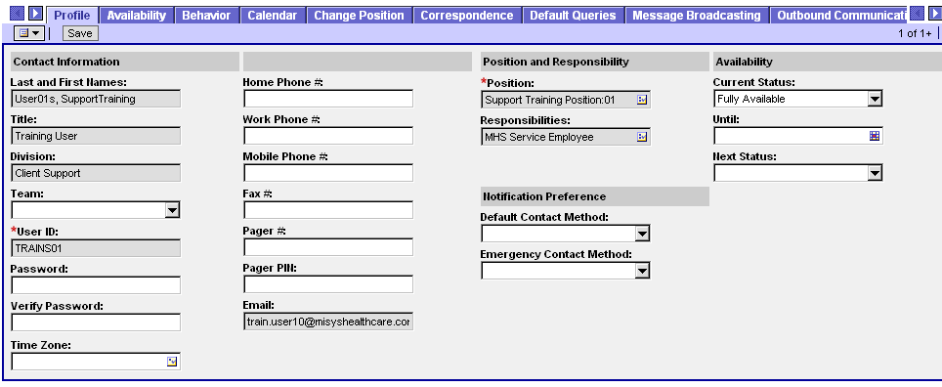

Caution: Some user preferences settings may not take effect until you log out and then log back in to your Siebel application.

Updating Profile and Behavior Settings
By clicking the Profile tab in the User Preferences screen, you can view your contact information, your position and responsibilities, and other information specific to you. Depending on your access privileges, you may be able to change your password here using the Password and verify Password fields.

Time Zone Preferences
You can specify which time zone your Siebel application uses to display date and time fields during your session.

To set a default time zone
- From the application-level menu, choose View > Preferences.
The User Preferences screen appears
- Click the Profile tab
The Profile form appears
- Click the Time Zone select button
The Pick Time Zone dialog box appears
- Select the desired time zone and click OK

Setting a Startup View
If you wish, you can determine which screen appears when you launch your Siebel application.

To set a startup view
1. From the application-level menu, choose View > Preferences.
The User Preferences screen appears
- Click the Behavior Tab
The Behavior form appears
- Click the Startup Screen select button
The Pick Favorite dialog box appears.
- From the Pick Favorite dialog box, select the screen and view you want to have for your startup view.
- Click OK
The screen and view now appear in the Startup Screen field.

Modifying the History List
You may wish to change the number of threads retained by the History list.

To modify the History list

- From the application-level menu, choose View > User Preferences
The User Preferences screen appears.
- Click the Behavior tab
The Behavior form appears
- Enter the number of threads you want the history list to retain in the Maximum Threads Saved field.

Setting Up Default Queries
Using the Default Queries tab in the User Preferences screen, you can set up queries to appear when you access a screen.

To make a query the default query for a view

- From the application-level menu, choose View > User Preferences
The User Preferences screen appears
- Click the Default Queries tab
The Screen Name and Screen View lists appear
- In the Screen Name list at the top of the screen, select the desired screen.
- In the Screen View list below the list of screens, select the desired view in the View Name column.

- Click the Default Query field next to the view you selected, and click the select button.
The Pick Query dialog box appears.

- From the Pick Query dialog box, select the query you want this view to display and click OK.

The selected query appears next to the appropriate view in the Default Query column.

View Personalization
You can show, hide, and resequence screen tabs and view tabs from the User Preferences screen. You can also set up default views for screens in your Siebel application.

To show or hide screen tabs

- From the application-level menu, choose View > User Preferences.
The User Preferences screen appears
- Click the Tab Layout tab
The Tab Layout list appears
- Select the row for the screen tab you wish to show or hide and do one of the following:
  - Clear the Hide check box to show the screen tab
  - Select the Hide check box to hide the screen tab.
Note: Hiding a screen tab hides all the views within that screen.

To show or hide view tabs
- From the application-level menu, choose View > User Preferences
The User Preferences screen appears
- Click the Tab Layout tab
The Tab Layout list appears
- In the Tab Layout list, select the row for the screen tab associated with the view tab you want to show or hide.

The View Tab Layout list shows the view tabs for the selected screen tab.
- In the View Tab Layout list, select the row for the view tab you want to show or hide and do one of the following:

  - Clear the Hide check box to show the view tab
  - Select the Hide check box to hide the view tab
Note: All the views available to you are always available through the Site Map, whether or not a view tab is hidden.

To change the order in which screen tabs appear
- From the application-level menu, choose View > User Preferences.
The User Preferences screen appears
- Click the Tab Layout tab
The Tab Layout list appears.
- In the Tab Layout list, select the row for the screen you want to reorder, and type a whole number in the Order field to define the position of the screen tab.

Note: If you use the same number in the Order field for more than one tab, the tabs with the same number will appear in alphabetical order. This applies to both screen tabs and view tabs.

To change the order in which view tabs appear
- From the application-level menu, choose View > User Preferences.
The User Preferences screen appears.
- Click the Tab Layout tab
The Tab Layout list appears
- In the Tab Layout list, select the row for the screen for which you want to reorder view tabs

The View Tab Layout list shows the view tabs for the selected screen.
- In the View Tab Layout list, type a whole number in the Order field for each view tab to define the position of that tab.

Note: The Order field defines the sequence of the tabs. The application uses the number in the Order field to resequence the tabs in ascending order. Use whole numbers only. This applies to both screen tabs and view tabs.

To set up a default view for a screen
- From the application-level menu, choose View > User Preferences
The User Preferences screen appears
- Click the Tab Layout tab
The Tab Layout list appears
- In the Tab Layout list, select the screen for which you want to set up a default view.
- In the View Tab Layout list, check the Default View check box for the view you want to have as the default for this screen.



Training Course Evaluation

Course Title______Siebel________________________ Date__________________

Please take a few moments to complete the following course evaluation. The information you provide will help us improve the content of the course and monitor the quality of our program.
If you would like a response about your comments and the action taken, please put your name on this critique!

Please select the answer that accurately corresponds with your evaluation of the topic being addressed.
5=Strongly 4=Agree 3=Acceptable 2=Disagree 1=Strongly NA=Not Applicable
Agree Disagree

- Course Content
  - Consistent with defined objectives 5 4 3 2 1 NA
  - Clear and well organized 5 4 3 2 1 NA
  - Ease of understanding 5 4 3 2 1 NA
  - Content appropriate and useful for my job duties 5 4 3 2 1 NA
  - Content was interesting and kept my attention 5 4 3 2 1 NA
Comments:

II. Course Format
- Lecture 5 4 3 2 1 NA
- Hands on training 5 4 3 2 1 NA
- Course was well paced 5 4 3 2 1 NA
- Length of course 5 4 3 2 1 NA
- Opportunities for questions 5 4 3 2 1 NA
Comments:

  - Instructor
- Knowledge of subject 5 4 3 2 1 NA
- Preparation for the class 5 4 3 2 1 NA
- Willingness to extend additional help 5 4 3 2 1 NA
- Provided a source of motivation 5 4 3 2 1 NA
- Presented himself/herself in a professional manner 5 4 3 2 1 NA
Comments:

IV. Overall I was satisfied with the course 5 4 3 2 1 NA

What one thing will you do differently as a result of your participation in this course?
____________________________________________________________________________________________________________________________________________________________

Suggestions for improvement for this course:
__________________________________________________________________________________________________________________________________________________________________________________________________________________________________________

